Programming the OLED Display.

The ESP-8266 Board we chose has a built in OLED display. This board was chosen to avoid soldering during the Dojo.

The OLED display is controlled by the SSD1306 chip. This chip is integrated in the display and ESP8266 Micro controller communicates with it using the I2C protocol.

The I2C protocol (https://en.wikipedia.org/wiki/I%C2%B2C) is well established serial communication protocol that allows multiple addressable devices to be connected on the same bus (wire). This minimizes the number of pins used and maximizes the number of peripherals possible.

The I2C protocol uses to connection/pins/wires, each is named according to the function it performs in the I2C protocol.

SCL: Serial Clock Line
SDA: Serial Data Line

it is not the scope of Dojo to explain how I2C works. However it is the focus to learn how to use it-

To use the I2C you need first to know Which pins on the ESP8266 is attached to SCL and SDA.

Also you need to know what is the Address of the SSD1306 chip on the I2C bus.

- SDA : D1
- SCL ; D2
- The SSD1306 is usually addressable on “0x3c” address.
- Screen dimensions 128 x 64 Dot Matrix

To use the SSD1306 you will need to install the library : “ESP8266 and ESP32 Oled Driver SSD1306 display”:

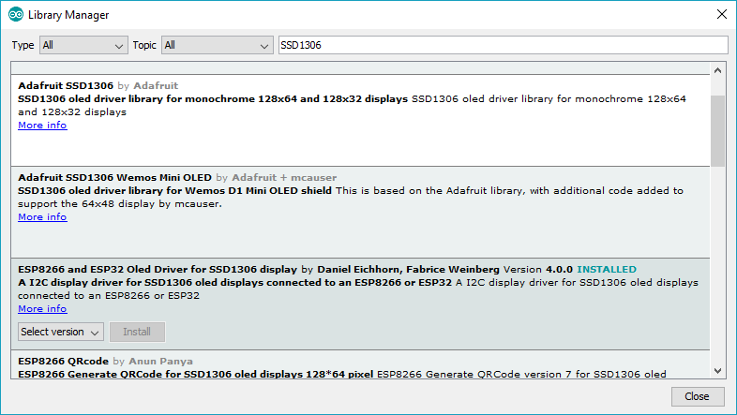

Then load and modify the following Example accordingly File→Examples → ESP8266 and ESP32 Oled Driver SSD1306 display → SSD1306SimpleDemo:
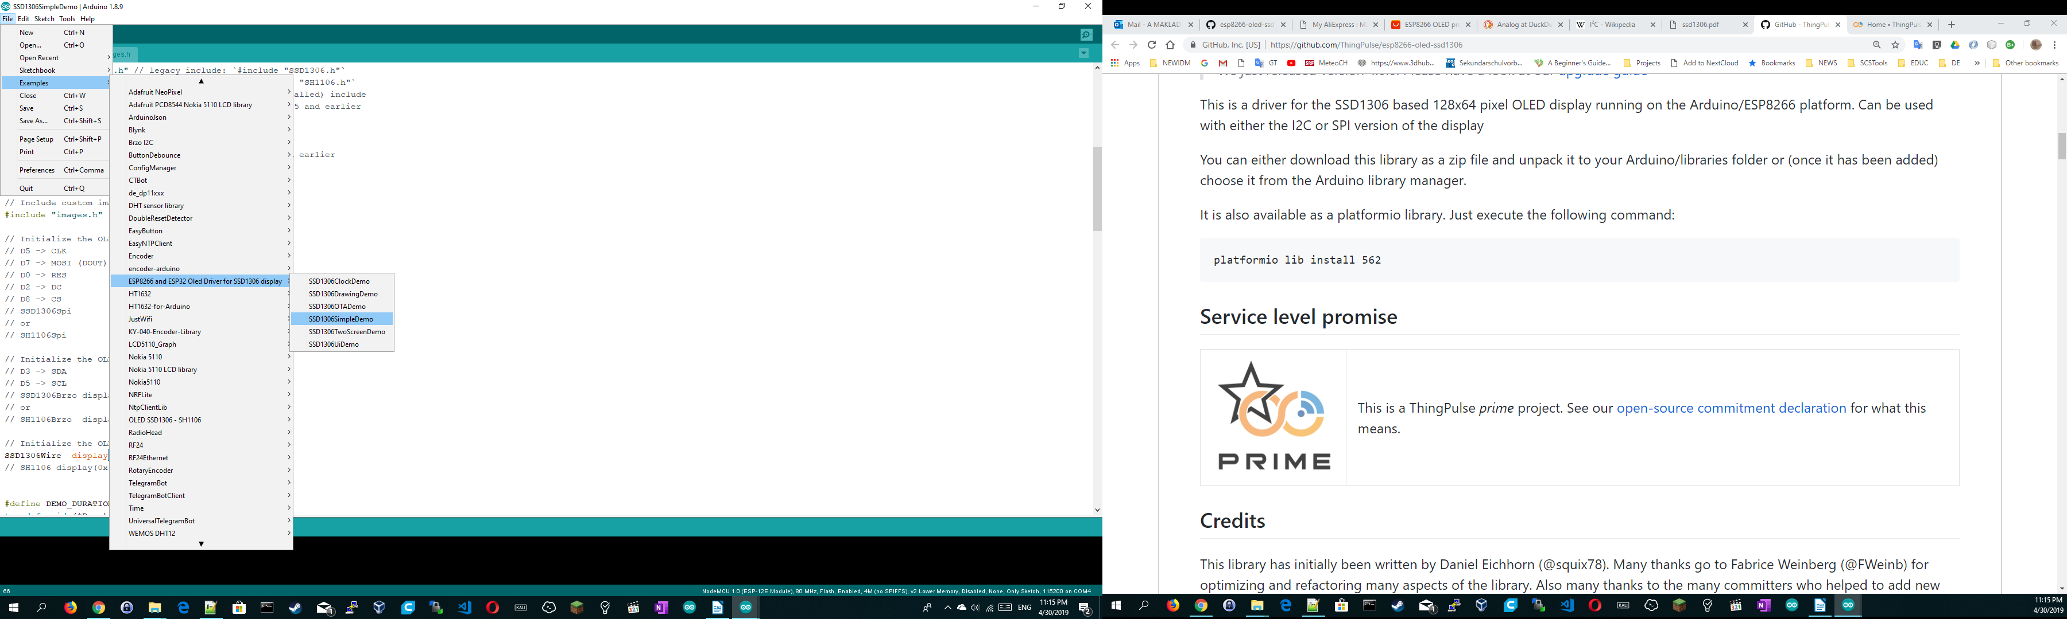

Modify the initialization line according to the SCL/SDA and address mentioned above:

// Initialize the OLED display using Wire library
SSD1306Wire display(0x3c, D1, D2);

Go through the code and learn the different functions for drawing a line and a string.

Also notice the statements and when they are called:

display.init();

display.display();

